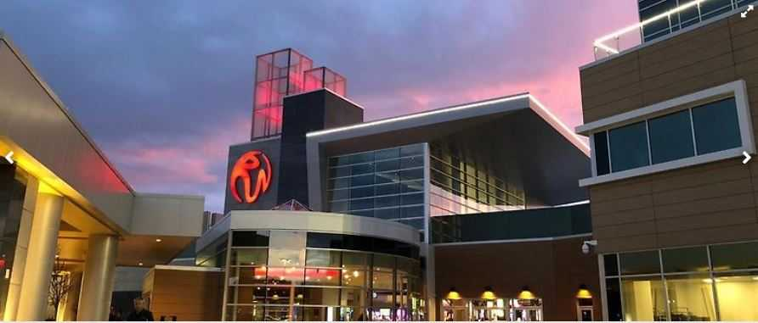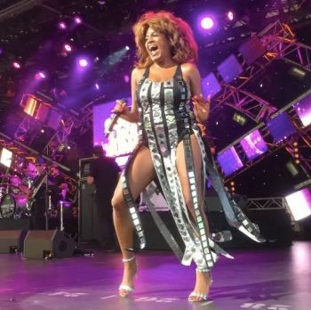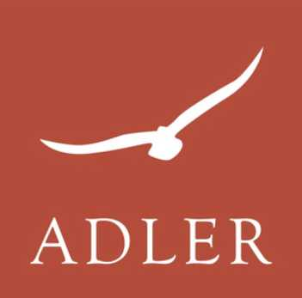

**ROCKY HILL SENIOR CENTER**

**Experience Magic at Resorts World Catskills**

**The Show You Don’t Want To Miss! Tina Turner's life was one of musical greatness and personal trauma, as she fled an abusive relationship, to achieve unlikely pop stardom in the ’80s with "What’s Love Got to Do With It."**

**Renowned for her sexy, elastic dance moves on stage, she toured relentlessly. "Private Dancer" played 180 dates in 1984, while subsequent tours filled arenas and stadiums worldwide.**

**Hidden in NY's scenic Catskill Mountains, Resorts World Catskills offers a Vegas-like thrill. Dive into 2,150 advanced slot machines, 150+ live table games, and a dynamic poker room. Elevate your adventure with our 2 days, 1-night package at The Alder, our latest hospitality gem. Beyond its plush stay, indulge in mesmerizing live entertainment, kick off with exclusive casino bonuses, and relish a grand buffet. Plus, with food vouchers in hand, explore diverse culinary delights. Recharge with a dip in our luxurious indoor pool or at the state-of-the-art fitness center. Dive into unparalleled luxury and excitement with us!**

**Double $299 Per Person**

**Single $350 Per Person**

**Triple $250 Per Person**

**Non-member add $10**

**Now Accepting Reservations!**

**Call (860) 258- 2786**

**Arrive Tuesday, May 14, 2024**

**Depart Wednesday, May 15, 2024**

**Musical Tribute to Tina Turner**

◻ **Overnight Lodging on Property at The Adler**

◻ **Luggage Handling**

◻ **$50 Slot Play ($25 On Arrival)**

◻ **$20 Food Comp (On Arrival)**

◻  **Live Show  (day 2)**

◻ **Full Buffet**

◻ **Luxury Transportation Included!**

◻ **All Service Charges & All Taxes**

**Casino Bonus Package Subject To Change**